**1. How to Run Code.**

1.1Open cmd and go the folder where the main.py file and data.txt is present. And enter command

**Python main.py**

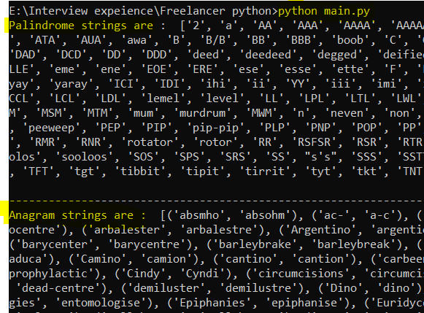

**2. Code documentation**

1. Reading the data.txt file (using **file handling** concepts )

with open ('data.txt', encoding='utf8') as f:

Storing all string data in (**data** = [])

1. Extracting only alphanumeric characteristic (using **isalpha(**) method for string )

String the filter data in (**str_data** = [])

1. Iterate the list str_data and call two methods:
   1. isPalindrome()
   2. isAnagram()
2. isPalindrome():

* Reverse the string and compare with original string if both are same, return True.
* str1 == str1[::-1]

**5.**isAnagram ():

5.1 Checking the length strings, they should be equal for Anagram, if not Return False.

5.2 Sort both string, if they are equal, return True else return False.

Output of Code:

